* **Conditional Probability**
* Definition:
* Formula:
* **General multiplication rule for two events**

**Practice:** The following table gives information on DVD players sold by a certain electronics store:

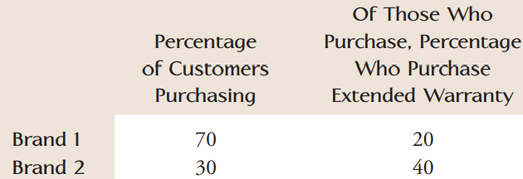A purchaser is randomly selected from among all those who bought a DVD player from the store. What is the probability that the selected customer purchased a Brand 1 model and an extended warranty?

* **Tree Diagram:**

Event 1 : You have a 0.65 probability of getting higher than average GPA and ACT scores.

Event 2 : If you have a higher than average GPA/ACT, you have a 0.83 chance of being admitted.

Event 3 : If you have a below average GPA/ACT score, you have a 0.39 chance of being admitted.

Define: H = Event of getting higher than average ACT/GPA

A = Event of being admitted to your dream school

Find: 1. P(H∩A) 2. P(A) 3. P(H|A)

* **The law of total probability**
* If B1 and B2 are ____________ events with ______________________ , then for any event E

P(E) =

* Generally, if B1, B2, … , Bk are ____________ events with ___________________________ , then for any event E:

P(E) =